BUS TICKET BOOKING APPLICATION

ADARSH RAJARAM HEGDE

**Screen shots of Application at Runtime:**

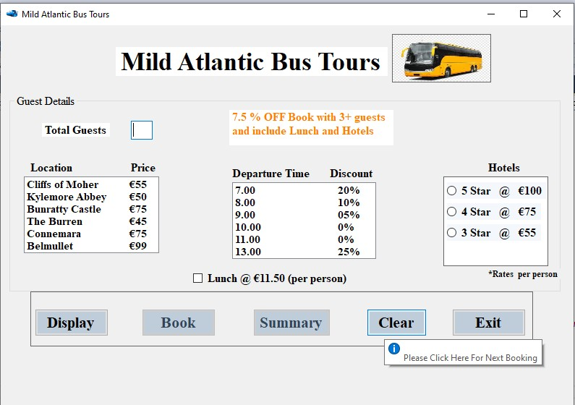

**Fig No.1 on Loading the Page**

**On Loading Page:-**

* **Focus is on the Total Guest Text Box.**
* **No Hotel Radio Button is invisible in Hotels Menu.**
* **Access Keys are used.**
* **Tooltip added for CLEAR and EXIT Button.**

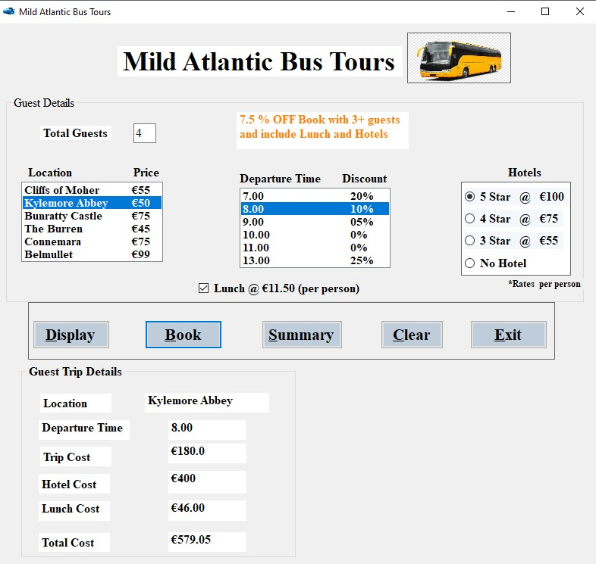

**Fig No.2 Displaying Guest Details.**

**Display Button:**

* All the correct values are selected and Display button is clicked.
* Focus shifted towards BOOK button.
* After clicking DISPLAY button No Hotel radio button is made visible and Customer can change their mind towards cancelling the hotel option.
* If the total guests are three or more than three than 7.5% of Discount is applied on Total Cost displayed in Guest Trip Details.

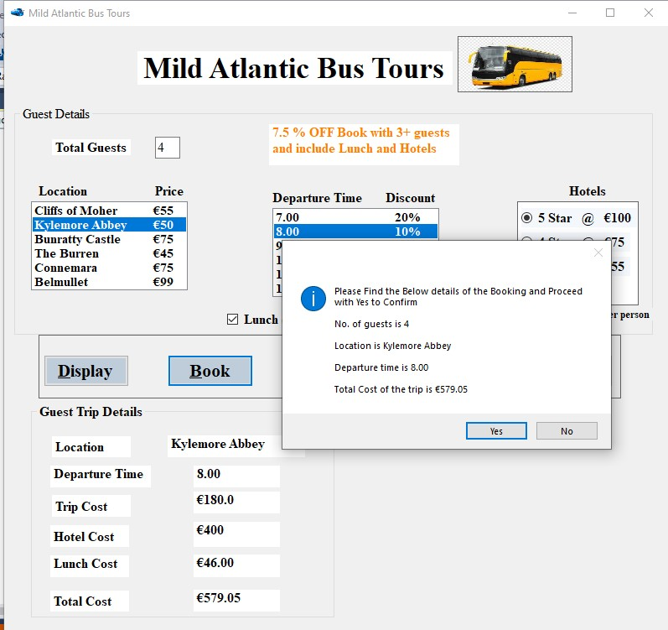

**Fig No.3 Booking Confirmation by Message box and events.**

**Book Button**

* **After Clicking the Book button, Message Box is displayed with Yes and No option.**
* **The selected options for guest are displayed to confirm it i.e. Departure time, Number of guests, Location Name.**
* **If Yes is clicked ticket is booked and transactions are added to database and If No is clicked than Clear button function is executed.**

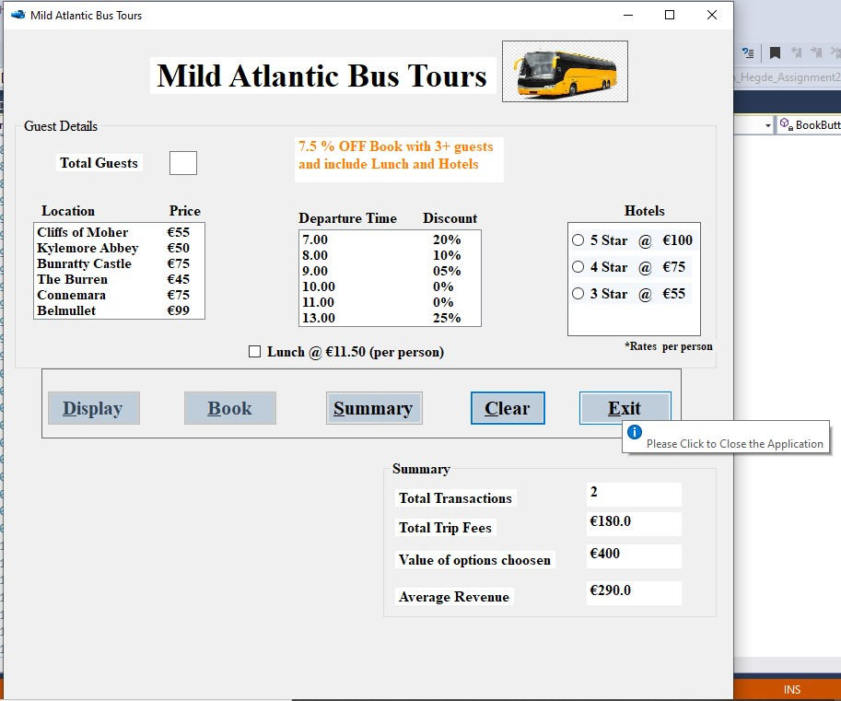

**Fig No. 4 Summary button output.**

**Summary button:**

* **On Clicking the Summary button, Summary id displayed. I.e. total transactions, Total trip costs, Average Revenue.**
* **On clicking the Summary button focus shifted to CLEAR button.**

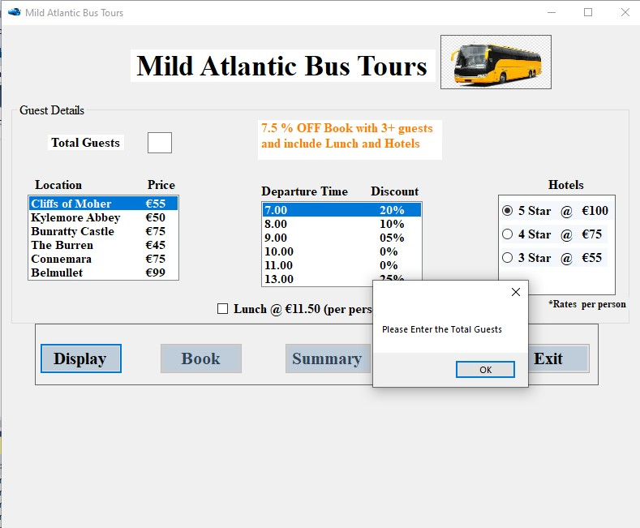

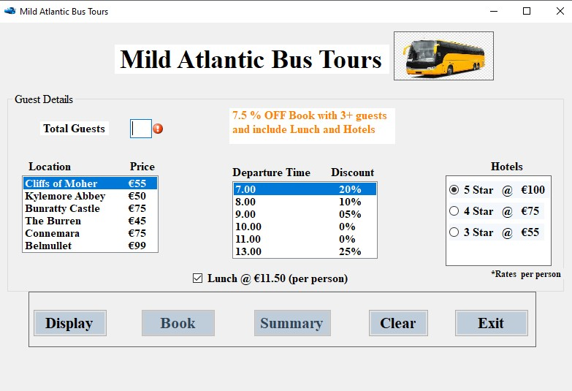**Fig No.5 Exceptional Handling for Null value in Textbox.**

**Fig No.6 Error provider tip added (Red error pop-up blinking symbol). Exception Handling:**

* **Three types are exceptions handled. I.e. null value or Negative value checking in Total guest ext Box, Index check in Location and price list box, Checking Departure list box.**
* **Error provider is used to point out which option causes the exception or error and when error occurs the same location error provider blinks.**

**Source Code:**

/* Student Name: Adarsh Rajaram Hegde

* Student ID: 20233217

* Date: 13/11/2020

* Assignment: 2
* Assignment: Create a form for Mild Atlantic Bus Tours sale team.

*/

**using** System**;**

**using** System**.**Collections**.**Generic**; using** System**.**ComponentModel**; using** System**.**Data**;**

**using** System**.**Drawing**; using** System**.**Linq**; using** System**.**Text**;**

**using** System**.**Threading**.**Tasks**; using** System**.**Windows**.**Forms**;**

**namespace** AdarshRajaram_Hegde_Assignment2_MS806

# {

**public partial** class Form1 **:** Form

# {

// Global Variable, Constants are declared and Intialized to 0. int TotalGuests**;**

const decimal DEPARTUREATSEVEN **=** 7.00m**,** DEPARTUREATEIGHT **=** 8.00m**,** DEPARTUREATNINE **=** 9.00m**,** DEPARTUREATTEN **=** 10.00m**,** DEPARTUREATELEVEN **=** 11.00m**,** DEPARTUREATONE **=** 13.00m**;**

const int CLIFFSOFMOHER **=** 55**,** KYLEMOREABBEY **=** 50**,** BUNRATTYCASTLE **=**

75**,** THEBURREN **=** 45**,** CONNEMARA **=** 75**,** BELMULLET **=** 99**;**

const decimal DEPARTUREAT7 **=** 0.2m**,** DEPARTUREAT8 **=** 0.1m**,** DEPARTUREAT9

**=** 0.05m**,** DEPARTUREAT13 **=** 0.25m**,** LUNCHCOST **=** 11.50m**,** DISCOUNT **=** 0.925m**;** const int FIVESTARHTOEL **=** 100**,** FOURSTARHOTEL **=** 75**,** THREESTARHOTEL **=**

50**;**

String LocationName**;**

decimal DepartureTime**=**0m**,**TotalCostValue**=**0m**,** TripCost**=**0m**,**

HotelCost**=**0m**,** LunchCost**=**0m**,** TotalCost**=**0m**,** TotalTransactions **=** 0m**,** TotalTripCosts **=** 0m**,** TotalLunchCost **=** 0m**,** AverageRevenue **=** 0m**,** ValueChoosen

**=** 0m**;**

decimal TotaLunchCostValue**=**0m**,** TotalHotelCostValue**=**0m**;**

**private** void RadioButton5Star_CheckedChanged**(object** sender**,** EventArgs

e**)**

# {

**}**

**private** void ClearButtonToolTip_Popup**(object** sender**,** PopupEventArgs

e**)**

# {

**}**

**private** void ButtonExit_Click**(object** sender**,** EventArgs e**)**

# {

//Exit Button which closes the application.

**this.**Close**();**

# }

**private** void groupBox2_Enter**(object** sender**,** EventArgs e**)**

# {

**}**

**private** void label9_Click_1**(object** sender**,** EventArgs e**)**

# {

**}**

**private** void label9_Click_2**(object** sender**,** EventArgs e**)**

# {

**}**

**private** void label7_Click_1**(object** sender**,** EventArgs e**)**

# {

**}**

**private** void LabelDepartureTimeValues_Click**(object** sender**,** EventArgs

e**)**

# {

**}**

**private** void RadioButton4Star_CheckedChanged**(object** sender**,** EventArgs

e**)**

# {

**}**

**private** void ButtonClear_Click**(object** sender**,** EventArgs e**)**

# {

//Clear button which clears the value in all labels and focus shifts to TotalGuest text box.

TextBoxTotalGuests**.**Text **=** ""**;** ListBoxLocationAndPrice**.**SelectedIndex **= -**1**;**

ListBoxDepartureTime**.**SelectedIndex **= -**1**;**

//unchecking the radio buttons. RadioButton5Star**.**Checked **= false;** RadioButton4Star**.**Checked **= false;** RadioButton3Star**.**Checked **= false;** CheckBoxLunch**.**Checked **= false;** LabelDepartureTimeValue**.**Text **=** ""**;** LabelTripcostValue**.**Text **=** ""**;**

LabelLocationNameValue**.**Text **=** ""**;** LabelTotalTripFessValue**.**Text **=** ""**;** LabelHotelCostValue**.**Text **=** ""**;** LabelLunchCostValue**.**Text **=** ""**;** LabelTotalCostValue**.**Text **=** ""**;** LabelTotalTransactionsValue**.**Text **=** ""**;** LabelTotalTripFessValue**.**Text **=** ""**;** LabelValueOfOptionChoosenValue**.**Text **=** ""**;** LabelAverageRevenueValue**.**Text **=** ""**;**

// code which makes buttons and Labels to invisible. ButtonBook**.**Enabled **= false;** RadioButtonNoHotel**.**Visible **= false;** ButtonSummary**.**Enabled **= true;**

ButtonDisplay**.**Enabled **= true;** GroupBoxGuestTripDetails**.**Visible **= false;** GroupBoxSummary**.**Visible **= false;**

// focus shifted towards total guest textbox. TextBoxTotalGuests**.**Focus**();**

# }

**private** void BookButton_Click**(object** sender**,** EventArgs e**)**

# {

// if yes option is clicked in Message Box options.

**if (**MessageBox**.**Show**(**string**.**Format**(**"Please Find the Below details of the Booking and Proceed with Yes to Confirm" **+** "\n\n" **+** "No. of guests is " **+** TotalGuests **+** "\n\n" **+** "Location is " **+** LocationName **+** "\n\n" **+** "Departure time is " **+** DepartureTime **+** "\n\n" **+** "Total Cost of the trip is "

**+** "€" **+** TotalCost**),** "\n\n"**,** MessageBoxButtons**.**YesNo**,** MessageBoxIcon**.**Information**) ==** DialogResult**.**Yes**)**

# {

TotalTransactions **=** TotalTransactions **+** 1**;** TotalCostValue **=** TotalCostValue **+** TotalCost**;** TotalTripCosts **=** TotalTripCosts **+** TripCost**;** AverageRevenue **=** Math**.**Round**((**TotalCostValue **/**

TotalTransactions**),**2**);**

GroupBoxGuestTripDetails**.**Visible **= false;** ButtonDisplay**.**Enabled **= false;** ButtonSummary**.**Enabled **= true;** ButtonBook**.**Enabled **= false;** ButtonClear_Click**(**sender**,** e**);**

TotaLunchCostValue **=** TotaLunchCostValue **+** LunchCost**;** TotalHotelCostValue **=** TotalHotelCostValue **+** HotelCost**;** ValueChoosen **=** TotalHotelCostValue **+** TotalLunchCost**;**

# }

**else{**

//if No is clicked in Message Box, Clear button is executed. ButtonClear_Click**(**sender**,** e**);**

# }

**}**

**private** void RadioButton3Star_CheckedChanged**(object** sender**,** EventArgs

e**)**

# {

**}**

**private** void RadioButtonNoHotel_CheckedChanged**(object** sender**,** EventArgs e**)**

# {

//if No Hotel button is clicked the Value of the Hotelcost is changed dynamically.

**if (**RadioButtonNoHotel**.**Checked**)**

# {

//calculations fro Total cost, trip cost and lunch cost. TotalCost **=** TripCost **+** LunchCost**;** LabelHotelCostValue**.**Text **=** "€" **+** 0.ToString**();** LabelTotalCostValue**.**Text **=** "€" **+** TotalCost**.**ToString**();**

# }

**else {**

// No Hotel button is not opted. LabelTripcostValue**.**Text **=** "€" **+** TripCost**.**ToString**();** LabelHotelCostValue**.**Text **=** "€" **+**

TotalHotelCostValue**.**ToString**();**

LabelLunchCostValue**.**Text **=** "€" **+** TotalLunchCost**.**ToString**();** LabelTotalCostValue**.**Text **=** "€" **+** TotalCost**.**ToString**();**

# }

**}**

**private** void LabelHotelCostValue_Click**(object** sender**,** EventArgs e**)**

# {

**}**

**private** void LabelLocationNameValues_Click**(object** sender**,** EventArgs

e**)**

# {

**}**

**private** void LabelTripcostValue_Click**(object** sender**,** EventArgs e**)**

# {

**}**

**private** void ButtonSummary_Click**(object** sender**,** EventArgs e**)**

# {

//calculations for Details in summary group box. LabelTotalTransactionsValue**.**Text **=** TotalTransactions**.**ToString**();** LabelTotalTripFessValue**.**Text **=** "€" **+** TotalTripCosts**.**ToString**();** LabelValueOfOptionChoosenValue**.**Text **=** "€" **+**

ValueChoosen**.**ToString**();**

LabelAverageRevenueValue**.**Text **=** "€" **+** AverageRevenue**.**ToString**();**

// code makes some parts of the form to invisible. GroupBoxSummary**.**Visible **= true;** GroupBoxGuestTripDetails**.**Visible **= false;** ButtonDisplay**.**Enabled **= false;**

ButtonBook**.**Enabled **= false;**

ButtonClear**.**Focus**();**

# }

**private** void TextBoxLunchCost_Click**(object** sender**,** EventArgs e**)**

# {

**}**

**public** Form1**()**

# {

InitializeComponent**();**

# }

**private** void listBox1_SelectedIndexChanged**(object** sender**,** EventArgs

e**)**

# {

**}**

**private** void listBox2_SelectedIndexChanged**(object** sender**,** EventArgs

e**)**

# {

**}**

**private** void Form1_Load**(object** sender**,** EventArgs e**)**

# {

// This is executed when form loads at first time. ButtonDisplay**.**Enabled **= true;**

ButtonBook**.**Enabled **= false;** ButtonSummary**.**Enabled **= false;** ButtonClear**.**Enabled **= true;** ButtonExit**.**Enabled **= true;** GroupBoxGuestTripDetails**.**Visible **= false;** GroupBoxSummary**.**Visible **= false;**

RadioButtonNoHotel**.**Visible **= false;**

// helps to focus on the Total guest Box.

**this.**ActiveControl **=** TextBoxTotalGuests**;**

# }

**private** void label6_Click**(object** sender**,** EventArgs e**)**

# {

**}**

**private** void label7_Click**(object** sender**,** EventArgs e**)**

# {

**}**

**private** void label8_Click**(object** sender**,** EventArgs e**)**

# {

**}**

**private** void label2_Click**(object** sender**,** EventArgs e**)**

# {

**}**

**private** void checkBox1_CheckedChanged**(object** sender**,** EventArgs e**)**

# {

**}**

**private** void label13_Click**(object** sender**,** EventArgs e**)**

# {

**}**

**private** void label9_Click**(object** sender**,** EventArgs e**)**

# {

**}**

**private** void textBox3_TextChanged**(object** sender**,** EventArgs e**)**

# {

**}**

**private** void label11_Click**(object** sender**,** EventArgs e**)**

# {

**}**

**private** void label14_Click**(object** sender**,** EventArgs e**)**

# {

**}**

**private** void label5_Click**(object** sender**,** EventArgs e**)**

# {

**}**

**private** void pictureBox1_Click**(object** sender**,** EventArgs e**)**

# {

**}**

**private** void textBox1_TextChanged**(object** sender**,** EventArgs e**)**

# {

**}**

**private** void ButtonDisplay_Click**(object** sender**,** EventArgs e**)**

# {

// error providers is cleared once values are selected properly. ErrorProviderLocatonListBox**.**Clear**();** ErrorProviderDepartureListBox**.**Clear**();** TextBoxTotalGuestErrorProvider**.**Clear**();**

// try block for exception handling.

# try

**{**

TotalGuests **=** int**.**Parse**(**TextBoxTotalGuests**.**Text**); if (**TotalGuests **>** 0**)**

# {

//checking Non negative total guests execption.

int LocationIndex **=**

ListBoxLocationAndPrice**.**SelectedIndex**;**

// null value exception.

**if (**LocationIndex **!= -**1**)**

# {

location list box.

// switch case to select the options from the

**switch (**LocationIndex**)**

# {

**case** 0**:**

TripCost **=** TotalGuests **\*** CLIFFSOFMOHER**;** LocationName **=** "Cliffs Of Moher"**; break;**

# case 1:

TripCost **=** TotalGuests **\*** KYLEMOREABBEY**;** LocationName **=** "Kylemore Abbey"**; break;**

# case 2:

TripCost **=** TotalGuests **\*** BUNRATTYCASTLE**;** LocationName **=** "Bunratty Castle"**; break;**

# case 3:

TripCost **=** TotalGuests **\*** THEBURREN**;** LocationName **=** "The Burren"**; break;**

# case 4:

TripCost **=** TotalGuests **\*** CONNEMARA**;** LocationName **=** "Connemara"**;**

# break; case 5:

TripCost **=** TotalGuests **\*** BELMULLET**;** LocationName **=** "Belmullet"**;**

# break;

**}**

int DepartureTimeIndex **=**

ListBoxDepartureTime**.**SelectedIndex**;**

**if (**DepartureTimeIndex **!= -**1**)**

# {

Departure time.

// checking for Null Value exception for listbox

**switch (**DepartureTimeIndex**)**

# {

selected.

TripCost**);**

//switch cases to parse the departure time

# case 0:

DepartureTime **=** DEPARTUREATSEVEN**;** TripCost **=** TripCost **- (**DEPARTUREAT7 **\***

# break;

TripCost**);**

TripCost**);**

TripCost**);**

**case** 1**:**

DepartureTime **=** DEPARTUREATEIGHT**;** TripCost **=** TripCost **- (**DEPARTUREAT8 **\***

# break; case 2:

DepartureTime **=** DEPARTUREATNINE**;** TripCost **=** TripCost **- (**DEPARTUREAT9 **\***

# break; case 3:

DepartureTime **=** DEPARTUREATTEN**; break;**

# case 4:

DepartureTime **=** DEPARTUREATELEVEN**; break;**

# case 5:

DepartureTime **=** DEPARTUREATONE**;** TripCost **=** TripCost **- (**DEPARTUREAT13 **\***

# break;

**}**

**if (**RadioButton5Star**.**Checked**)**

# {

// Radio button for hotels.

HotelCost **=** FIVESTARHTOEL **\*** TotalGuests**;**

# }

**else if (**RadioButton4Star**.**Checked**)**

# {

// Radio button for hotels.

HotelCost **=** FOURSTARHOTEL **\*** TotalGuests**;**

# }

**else if (**RadioButton3Star**.**Checked**)**

# {

// Radio button for hotels.

HotelCost **=** THREESTARHOTEL **\*** TotalGuests**;**

# }

**if (**CheckBoxLunch**.**Checked**)**

# {

// Lunch cost check box calculation. LunchCost **=** TotalGuests **\*** LUNCHCOST**;**

# }

**if (**TotalGuests **>=** 3**)**

# {

discountis applied.

**+** LunchCost**);**

// if there are guests >=3, than 7.5% TotalCost **=** DISCOUNT **\* (**TripCost **+** HotelCost

# }

**else**

# {

// if total guests are less than 3 and Total cost is calculated without Discount.

TotalCost **=** TripCost **+** HotelCost **+** LunchCost**;**

displayed. LocationName**.**ToString**();** DepartureTime**.**ToString**();** TripCost**.**ToString**();**

HotelCost**.**ToString**();** LunchCost**.**ToString**();** TotalCost**.**ToString**();**

# }

**else**

# {

**}**

// Values in Group box guest trip details are LabelLocationNameValue**.**Text **=** LabelDepartureTimeValue**.**Text **=** LabelTripcostValue**.**Text **=** "€" **+**

TotalCost **=** Math**.**Round**(**TotalCost**,** 2**);** LabelHotelCostValue**.**Text **=** "€" **+**

LabelLunchCostValue**.**Text **=** "€" **+**

LabelTotalCostValue**.**Text **=** "€" **+**

//code to make invisible some part of the form. ButtonDisplay**.**Enabled **= true;** ButtonSummary**.**Enabled **= true;** ButtonBook**.**Enabled **= true;**

ButtonClear**.**Enabled **= true;** ButtonExit**.**Enabled **= true;** GroupBoxGuestTripDetails**.**Visible **= true;** ButtonBook**.**Focus**();** RadioButtonNoHotel**.**Visible**= true;**

// Null value exception for departure time list

box. Time"**);**

MessageBox**.**Show**(**"Please Select the Departure

ErrorProviderDepartureListBox**.**SetError**(**ListBoxDepartureTime**,** "Please Select the Location"**);**

# }

**}**

# else

**{**

//Null vlaue execption for Location listbox. MessageBox**.**Show**(**"Please Select the Location"**);**

ErrorProviderLocatonListBox**.**SetError**(**ListBoxLocationAndPrice**,** "Please Select the Location"**);**

# }

**}**

# else {

//Negative value exception for total number of guests. MessageBox**.**Show**(**"Please Provide Positive Whole Number in

Total Guests Option"**);**

# }

**}**

# catch

**{**

// catch blocks for Total number of guests.

MessageBox**.**Show**(**"Please Enter the Total Guests"**); this.**ActiveControl **=** TextBoxTotalGuests**;** TextBoxTotalGuestErrorProvider**.**SetError**(**TextBoxTotalGuests**,**

"Please Enter The Total Guests"**);**

# }

**}**

# } }